Brooklyn torah gazette
Vayakhel-pekudei 5778
Volume 2, Issue 27 (Whole Number 70) 23 Adar 5777/ March 10, 2018
Printed L’illuy nishmas Nechama bas R’ Noach, a”h

For a free subscription, please forward your request to keren18@juno.com

For MU Students, Keeping Kosher is More than Just a Diet
By Tashan Reed

Kosher culture is much more than just skipping out on bacon in the morning; it's a way of life

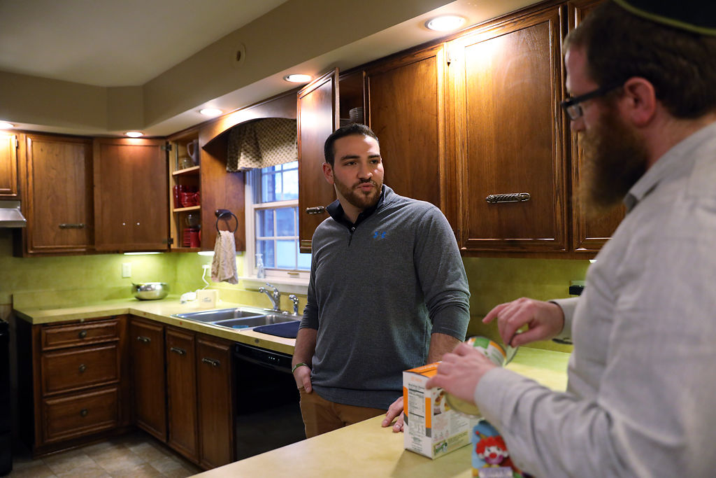
Jason Peiser meets with Rabbi Avraham Lapine at Lapine's house to talk about kosher food. Photo by Meiying Wu.
Jason Peiser, a business management major at MU [University of Missouri at Columbia], was originally drawn to the Chabad House for the food, but three years later it has become a second home to him. The house is kept stocked with kosher food for students to have access to during the week.
Like millions of other Americans, Jason Peiser hosted a potluck for his friends to watch the Super Bowl. Unlike many of those millions, Peiser could only eat two of the many dishes laid before him. Peiser, a senior at MU, is Jewish, and he’s keeping kosher.
Food trucks, dining halls and restaurants are increasingly catering to dietary restrictions, gluten- and dairy-free, for example. However, religious diets such as kosher are harder to maintain, especially in smaller cities. Mizzou Hillel, a group dedicated to enriching the lives of Jewish students, estimates that there are only 700 Jewish undergrads at MU. That accounts for just 3 percent of the student population.


Rabbi Avraham Lapine explains that his family has blue plates for dairy and red ones for meat, and they have to be kept separately at his house. Photo by Meiying Wu.

Rabbi Avraham Lapine explains that his family has blue plates for dairy and red ones for meat, and they have to be kept separately at his house.
Peiser is currently the president of Chabad Mizzou. The Jewish organization runs through The Chabad House, which is open 24 hours and holds Shabbat dinner, which occurs every Friday. Despite his many years of involvement in the Jewish community, Peiser considered himself a secular Jew and ate whatever he wanted. That all changed with an enlightening trip to Jerusalem last summer, which motivated him to become more observant.

What is kosher?
Rabbi Lapine and Mizzou Hillel’s Jeanne Snodgrass explain the nitty-gritty of eating kosher. The word kosher actually means that it’s fitting for a Jew to eat. Here are a few products that are kosher.
Produce: Fruits and vegetables. Greens are washed and checked for bugs, which aren’t permitted to be eaten under kosher law.
Packaged goods:Products are marked with a “U” or “K.” These are called hechshers and signify they’re kosher. Rabbis who are part of koshering organizations go to where the food is being produced, harvested or cooked to ensure it meets all requirements.
Fish: Only fish that have fins and scales are kosher. This rules out shellfish and catfish, for example.
Meat: Animals that have cloven hooves and chew their cud (when animals chew digested food a second time) are permitted. “A pig has split hooves but doesn’t chew its cud, so it has half the signs of a kosher animal, but it’s not kosher,” Lapine says.
Dairy and meat: Meat and dairy cannot be mixed under any circumstances, though each can be eaten separately. “So, you can’t have a cheeseburger, even if all the ingredients are kosher,” Lapine says.
Sarah Kusnitz, another MU student, is currently studying at Hebrew University in Israel. She went to a Jewish boarding school and remained active at MU by joining Jewish sorority Sigma Alpha Epsilon Pi. Like Peiser, she became a member of Chabad Mizzou.
For both students, keeping kosher at MU has been difficult. Kosher meat is hard to find and expensive. Peiser’s unconventional route to kosher living has come with some added challenges. “For the first 3 ½ years at Mizzou, I ate everything, so I know what I’m missing by not eating meat out at restaurants or eating pork,” Peiser says.
He’s resigned to eating most of his meals at home. “If I don’t have meat, I can’t just run to the store and buy it,” Peiser added. He must either make the drive himself or wait for Rabbi Avraham Lapine, Chabad Mizzou’s rabbi, to bring him meat from Kansas City or St. Louis because Columbia doesn’t have a kosher butcher.
To help cope with the inconvenience, Peiser allows himself to eat out but chooses vegetarian options. “At home, I won’t mix dairy and meat, and I won’t eat meat that’s not kosher,” Peiser says. Kosher diets typically include these stipulations due to concerns over contamination, but Peiser doesn’t keep strict kosher. “Every rabbi will say you have to ease into it,” Peiser says. “If you go from being totally secular to all of the sudden you’re growing a beard and keeping strict kosher, it’s going to scare you away.”
Kusnitz, however, does adhere strictly to a kosher diet and says she sees it as a way to bring Judaism into every aspect of her life and feel a sense of community.
Though there are different reasons people choose to be kosher, Rabbi Lapine explains that the concept ‘you are what you eat’ is relevant. “You are affected by the food you eat. Therefore, G-d doesn’t want anyone to have any negative attributes, that’s why all the animals that are kosher are only tame animals, not wild carnivores,” he says.
Both students use the value behind keeping kosher as motivation. For Peiser, it’s about following what “the holy Jews in the past did.” At MU, those keeping kosher are challenged by inconvenience, a lack of options and a small Jewish population. That struggle, however, is part of what brings them closer.

Reprinted from the February 22, 2018 edition of VOX Magazine, published in Columbia, Missouri. Rabbi Abraham Lapine is co-director of Chabad Mizzou at the University of Missouri at Columbia.

Thoughts that Count
For Parshat Vayakhel
And Moses gathered together all the Congregation of the Children of Israel and said to them: "These are the things which G-d has commanded that you should do" (Ex. 35:1)
Every Jew approaches a mitzva with his own personal thoughts and intentions, according to his intellect and level of understanding. Yet the physical performance of the mitzva is carried out in the same manner by all. Moses was able to assemble all the Jews together in true unity because the performance of mitzvot is common to all Jews, no matter what their other differences may be.
(Rebbe of Tshortkov)
On the seventh day there shall be to you a holy day (Ex. 35:2)
Rabbi Bunim once said: There is no other mitzva as all-encompassing as that of sukka. A person actually enters the mitzva with his whole body, his clothes, and even his shoes.
Rabbi Shlomo Leib of Lentashna responded: The mitzva of Shabbat is even greater. One need not lift a finger to bring it on; Shabbat arrives by itself. And, the holiness of Shabbat totally encompasses everyone and everything for more than 24 hours. Reprinted from Issue #205 of L’Chaim Weekly (Parshat Vayakhel 5752/1992).
What Does Maimonides
Say About Evolution?
By Daniel Balas

Maimonides addressed the idea of an "Ancient World" but what does that have to do with evolution?

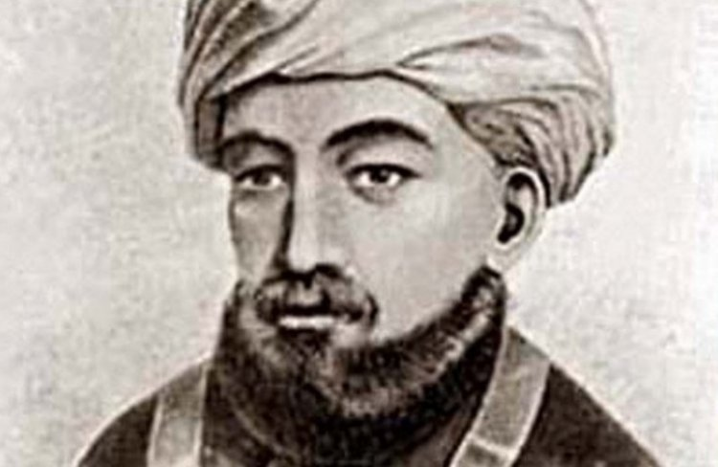
Maimonides, Rabbi Moshe ben Maimon

Maimonides, Rabbi Moshe ben Maimon, lived 800 years ago. He was known as one of Judaism’s leading philosophers, a doctor and scientist. His magnum opus was the Yad Hachazaka, a 14-volume work on Jewish law. He authored many other works including “The Guide to the Perplexed,” one of Jewish philosophy's great work. He also authored the Ani Maamin, the 13 Fundamentals of Faith which is a succinct summary of the foundations of Judaic Faith. Therefore it’s logical for us to seek out what he wrote in his works that would help answer our questions about evolution.
If you would've asked a heretic a hundred (or even a thousand) years ago what he believed about the world, you would hear him say, “The world always was; it’s ancient and primordial.” This was the centuries-old equivalent of the theory of evolution that we have today!
Many people are unaware that the philosophers and scientists in the olden days all believed that the world was ancient; in other words, a static universe that always existed, forever, with no point of beginning. The heretics also adopted this theory for obvious reasons: "If the world always was then there was no Creator and I owe nothing to anyone! The world always was and that’s it!" This, they felt, let them off the hook. They had a vested interest in their belief.
There were, however, many people who believed in the ancient world idea simply because the philosophers and scientists said so. The philosophers and scientists of yore, similar to what we have today, were granted the blind faith of the masses in everything they said. ”There is nothing new under the sun.”
If you have an academic degree, you may consider yourself able to analyze information discard what does not stand up to scrutiny. But when it comes to evolution all these tools used to analyze and scrutinize are generally laid to rest. That is how, in our generation, unfounded theories like evolution become academically supported and accepted “facts,” at least until they are disproven.
Here is more news for those of us who have heard of the “Big Bang Theory.” Thanks to this theory, the “Ancient World Theory” was finally laid to rest only recently, in these past 100 years.



Even Albert Einstein himself originally believed in the ancient “static world” theory. Only Hubble’s discoveries in astronomy in the last 70 years caused Einstein, with most other scientists, to throw the static world theory in the wastebasket. Seeing that all the heavenly bodies are moving away from each other prompted all the scientists to agree that there was a beginning which they called “The Big Bang.” Einstein admitted at the time that his belief in a static world was “the biggest mistake of my life.”
All in all, theories just don’t disappear; rather, they undergo a metamorphosis! The Ancient World theory morphed into the theory of evolution. The same exemption from having a G-d comes into play here, too. Much to our delight, Maimonides addressed the Ancient World theory in his philosophical work “The Guide to the Perplexed.” His answer there is the same answer we will use today when addressing evolution and the age of the world.
What is his answer?
To be continued... (Reprinted from the website of Hidabroot.com)

Rabbi Akiva Eiger and the Borrowed Copy of the Rashba

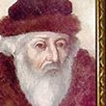

R' Avraham Shmuel Binyamim Sofer (The "Ksav Sofer") once related the following: R' Akiva Eger (1761-1837) and one of his sons were traveling together and found themselves behind schedule.
As the sun set, they were still far from their destination. Being strangers in town, they searched for a door with a Mezuzah and knocked, whereupon they were warmly received by the family that lived there.
After resting briefly, R' Eger and his son involved themselves in a deep Talmudic discussion. Their studies eventually touched on a certain comment of R' Shlomo ben Aderet ("Rashba"). R' Eger asked his host if he owned a copy of the that commentary, and the host procured an old, dusty volume of Rashba.
The two scholars poured over the relevant passage for a long time. Finally, their discussion came to a close. Before they retired for the night, R' Eger asked his host for a pen and a sheet of paper. In the morning, R' Eger's son was astonished to see that his father had recorded verbatim and from memory an entire page which was missing from their host's Rashba.
To this story the Ktav Sofer added: "This story shows much more than my grandfather's (R' Eger) genius. His love of Torah was so intense that he could not bear to see a volume of Rashba incomplete. He therefore took the time and effort to complete it." (Love of Torah)

Reprinted from the Parshat Vayakhel-Pekudei 5778 email of whY I Matter parsha sheet of the Young Israel of Midwood (Brooklyn) edited by Yedidye Hirtenfeld.

Rav Menachem Azaryah
Of Fano, Zatz'l

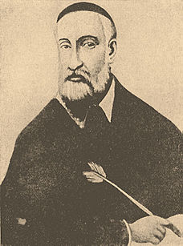
Rav Menachem Azaryah of Fano zatz'l Rav Menachem Azaryah [5307 (1547) - 4 Av 5380 (1620)] is known as the "Rama Mi'Fano" after his initials and his hometown. He was also known as Rav Emanuel. (He should not to be confused with "Rema"--Rav Moshe Isserles.) Rama was a leading scholar and philanthropist in Italy. His teachers included Rav Yishmael Chananiah of Vallmontone and Rav Ezra of Fano.
Rama used his great wealth to support the poor as well as to publish sefarim (Torah works). Besides his own works, he was responsible for the publication of classic works including Rav Yosef Karo's Kessef Mishneh and some works of Rav Moshe Cordevero ("Remak").
Rama was accomplished in Talmud, halachah, and kabbalah. His best known works are in the last of these fields. Originally he was a disciple (from a distance) of Remak. However, when Rav Yisrael Seruk, a disciple of Arizal, arrived in Italy in 5357 (1597), Rama became Rav Yisrael's student.
Rama is credited with playing a decisive role in making Arizal's system of kabbalah study the predominant one. Indeed, because Rav Yisrael Seruk was among the earliest students of Arizal, Rama's writings transmit teachings which are not found elsewhere.
Rama's work Asarah Ma'amarot addresses the moral and ideological lessons of kabbalah, rather than its technical side. It also explains many verses and Talmudic statements.
In Ma'amar Chikur Ha'din (II:28), Rama observes that there is a difference between the term "nachalah" and "yerushah"--both of which mean "inheritance." The former word is related to "nachal"--stream--and is used repeatedly in this parashah when referring to inheritance which flows directly from a father to a son (just as a river flows continuously and directly).
The latter term is used when referring to indirect inheritance, whether a son inheriting from a mother, a brother from a brother, or a daughter from a father. The Torah says (Devarim 18:20), "Righteousness, righteousness shall you pursue, so that you will live and possess ('ve'yarashta') the Land that Hashem, your G-d, gives you."
Rama writes that the Torah uses a form of the word "yerushah" (the less direct inheritance) here in order to teach that we should not feel certain about holding-on to Eretz Yisrael. Similarly, the Torah is called a "morashah" (Devarim 33:4) because a son cannot inherit it from his father. Torah must be acquired by each person independently. [Hamaayan]

Reprinted from the Parshat Vayakhel-Pekudei 5778 email of whY I Matter parsha sheet of the Young Israel of Midwood (Brooklyn) edited by Yedidye Hirtenfeld.

A Contemporary American-born
Torah Gadol – Rav Belsky
By Daniel Keren

(“Rav Belsky: The Life of a Multi-Dimensional Gadol: Rosh Yeshivah, Rabbi, Posek, Genius, Adviser and Friend” by Rabbi Shimon Finkelman, 581 pages, ArtScroll/Mesorah Publications, 2017)

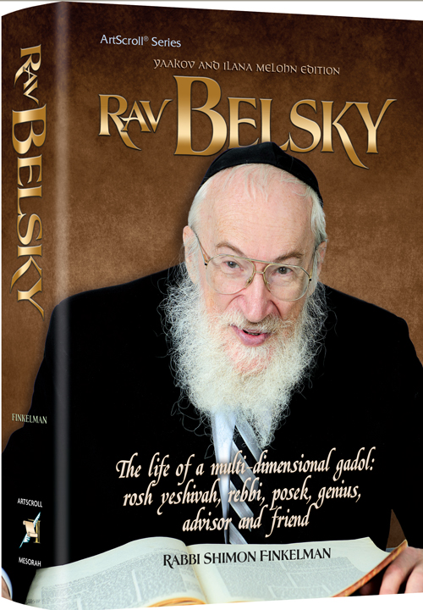

ArtScroll/Mesorah Publications has just released a definitive biography of Rav Chaim Yisroel Belsky, zt”l, one of the first of the major Torah Gadolim to have been born in America.
The legendary career of Rav Belsky as a Marbitz Torah goes back to the Spring of 1964 when at the tender age of 25 while still learning in the Torah Vodaath Kollel, he was asked to substitute for Rabbi Zelik Epstein, at the time one of the renowned maggidei shiur (Torah lecturers) in the Torah Vodaath beis midrash who had suffered a heart attack. His performance was so outstanding that Rav Belsky continued to teach in the Torah Vodaath beis medrash for the next 52 years until his petirah two years ago (19th Shevat 5776/January 28, 2016) at the age of 77.
Rav Belsky as a child when the family lived in the Williamsburg section of Brooklyn was enrolled in Torah Vodaath, a pioneer American Orthodox Jewish yeshivah that had been founded by his maternal grandfather – Reb Binyomin Wilhelm. And with the exception of a brief few years learning at the Bais Medash Elyon in Monsey [itself an outshoot of Torah Vodaath), Rav Belsky returned to learn at the Torah Vodaath Kollel before dedicating the rest of his productive life as a Torah scholar and teacher at his alma mater.
Before his fame spread far and wide across the Torah world, Rav Belsky was renowned in the Torah Vodaath community as a teenage prodigy and masmid (diligent Torah student). From the start even as an elementary school student, his natural genius was recognized.
Rabbi Finkelman records in his new biography how when in the third grade Yisroel Belsky had done so well on standard I.Q. tests prepared by the New York State Board of Education that a delegatrion top state educators with the cooperation of the Torah Vodaath elementary yeshiva principal and his English math teacher made a surprise visit to Yisroel Belsky’s classroom.
His teacher than asked the youngster to take over teaching the class and to the amazement of the secular educational experts, young Yisroel Belsky did a quite remarkable performance by glancing at the teacher’s textbook and relaying the information in a confident and effective manner to his fellow classmates.
But many individuals have had inborn talents to learn and yet failed to develop into brilliant scholars or teachers. What was Rav Belsky’s secret? In Chapter Ten of “Rav Belsky,” titled “Wellspring of Torah,” Rabbi Finkelman records:
“A talmid asked Rav Belsky, “What defines someone as a gadol baTorah [an outstanding Torah teacher/personality]? He responded, “Chazarah [reviewing the material you’ve learned] is what separates the men from the boys.” On his talmidim’s semichos [rabbinical ordination diplomas], he wrote that he [Rav Belsky] is conferring semichah, “…Ubilvad sheyachzor alav kol yamav (on condition that he will review the material for the rest of his life.”).
“Rav Belsky did not rely on his superior memory to retain what he had learned.
“A renowned rav [Rabbi Heshy Wofl] described their first encounter: “I asked Rav Belsky questions from all four sections of the Shulchan Aruch [Code of Jewish Laws] and he responded by quoting passages from Shach and Magen Avraham and other commentaries verbatim! Our conversation lasted some 40 minutes. When we finished, I asked him, ‘How does the Rosh Yeshiva know everything so fluently?’ He responded, ‘Review, review, and review.’”
Over the course of a half-century career as a Marbitz Torah, Rav Belsky taught perhaps close to a thousand students, many of whom like Rabbi Yisroel Reisman and Rabbi Elya Brudny have gone on to be outstanding Torah teachers themselves. But the greatness of Rav Belsky extends to almost all aspect of both Torah and the realm of adam li’chavero (helping fellow Jews) regardless of their level of Yiddishkeit, their ability to learn Torah or other personalities defects that would frequently turn off other teachers of a similar caliber.
His love for his talmidim was so obvious and in his mind was the secret of his great success in inspiring so many to strive for their own greatness in both Torah learning and in the performance of mitzvahs. In his last quarter of a century of life in addition to faithfully maintaining his heavy teaching load at Torah Vodaath, Rav Belsky became one of the most important experts on practical and technical kashrus issues, as well as an important posek (clarifier) in all aspects of Torah law.
While reading “Rav Belsky: The Life of a Multi-Dimensional Gadol: Rosh Yeshiva, Rebbi, Posek, Genius, Adviser, and Friend” by Rabbi Shimon Finkelman, [a multi-talented writer and teacher of Torah in his own right] is not going to transform you into a brilliant Torah scholar, it will inspire the sensitive reader to push himself or herself to learn better and to try and emulate Rav Belsky in the important realm of middos tovos with regards to others who certainly could use our understanding, kind words and cheerful smiles. The easy-to-read book is available in Jewish bookstores or by contacting the publisher by calling (800) 637-6724 or clicking www.artscroll.com

Thoughts that Count
For Parshat Pekudei

These are the accounts of the Tabernacle (Ex. 38:21)

Moses fully accounted for all the materials which went into crafting the Tabernacle. We can understand why he listed exactly how much gold, silver and gems were used; they are highly valuable. But why did he account precisely for the copper, which has so little comparative value?
The copper was not a compulsory tax. The Torah recognizes that it is often those who give "freely" but less than they are truly able who demand the strictest accounting of every penny. For they are ever on the lookout for an excuse not to give any more.
Reprinted from Issue #206 of L’Chaim Weekly (Parshat Pekudei 5752/1992).
Rabbi Berel Wein on Parshat Vayahkhel-Pekiudei

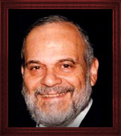

The commentators over the ages who have studied every word of the Torah carefully and meticulously particularly note that the review and accounting for the construction of the Mishkan/Tabernacle was preceded by convening all of the Jewish people before Moshe and once again reviewing the laws and importance of Shabbat.
The main and obvious lesson to be derived from this juxtaposition of subject matter is that Shabbat is supreme even over the construction of the holy house of G-d itself. Though the construction of the Mishkan/Tabernacle was not allowed on Shabbat, nevertheless once the structure was erected and operating the services in that very edifice continued even on Shabbat with the special Shabbat offerings as prescribed in the Torah.
There is a very subtle but meaningful message hidden in this seeming contradiction as to the actual practical supremacy of Shabbat over the Mishkan/Tabernacle. After all, if the Jewish people were prohibited from building and constructing the Mishkan/Tabernacle on Shabbat then why were they allowed and in fact commanded to operate and conduct the sacrificial service in that building on Shabbat? There seems to be a disparity of ideas regarding this matter.
Much has been written on the subject but there always is room for new ideas and different insights. This is what makes the Torah eternal and refreshes it in every generation and under all circumstances. It speaks to all times and provides guidance to all the differing ages and histories of humankind. So, I have an idea that I wish to share with you regarding this issue.
The overriding prohibition of work on Shabbat is that of doing creative work. That is the core of the laws of Shabbat as they pertain to work on the holy day. Over the centuries, Jewish tradition has overlaid layers of prohibitions to safeguard the Shabbat but in essence global prohibition for work on Shabbat remains a prohibition to do creative work.
This is an example of our attempt to imitate the Creator who, so to speak, finished all creative work in establishing our universe and therefore no creative work was performed any longer on the seventh day of creation. This is the template for our understanding of Shabbat. The Lord rested, so to speak, on the seventh day, however we will understand this and interpret it, from the creative nature of establishing our universe.
It is therefore understandable that our observance of Shabbat should be concentrated on creative work and that we emulate our Creator, so to speak, by refraining from any further creative work. However just as nature proceeds to operate on the seventh day as it does on all other days of the week, the idea of nature being a creative piece of work diminishes.
Building the Mishkan/Tabernacle in the desert was a triumph of creativity and ingenuity, of Godly inspiration and human talent. It therefore follows that the final Torah reading of the Book occurs on the Sabbath since that day represents the cessation of G-dly creativity as far as our universe is concerned.
Once the Mishkan/Tabernacle was in place and built however then it resembled nature in its continuity and flow of activity. Thus even on Shabbat the normal flow of Temple services continued.

Reprinted from this week’s RabbiWein.com website
Rabbi Eli J. Mansour on
Parashat Vayakhel-Pekude

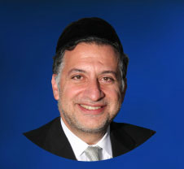

Parashat Vayakhel opens up with the law of Shabbat. It tells us six days we go to work, and on Shabbat we rest, we take off, and we are not allowed to do Melacha (work.) Following that, we read about the Mishkan. We read about the funds that were collected, and what they did with the monies of the Mishkan, and actually the whole story is reviewed. All the Rabbis ask, what is the connection between Shabbat and the Mishkan? Why does the Torah juxtapose them next to each other?
There’s a Midrash that approaches this subject. The Midrash starts off and says that the Torah came in front of G-d and asked a question. The Torah asked, what is going to be with me once the Jewish people enter the land of Israel. Some Jews will be dealing with their vineyards, and other Jews will be dealing with their fields and will become land owners. So how will it be, the Torah asks, that the Jews will have time to study Torah?
The Torah asks, ‘What is going to be with me?’ In the desert people had time on their hands. Nobody owned real estate. There was nothing for them to do except to learn Torah. The Torah was getting concerned what would happen once the Jews enter the land of Israel, since the Jews would need to attend to their properties, and they will not have time learn Torah anymore.
G-d answered that he has a mate for the Torah, a partner for Torah. And it is called Shabbat. Because on that day the Jewish people are not allowed to work and therefore they are going to have no choice but to sit and study Torah.
The Yerushalmi writes on this topic. It writes that Rabbi Chagai says that the purpose of Shabbat and Yom Tov is so people can sit down and eat well and drink well. But Rabbi Ben Achaya argues on this and says that Shabbat was given to immerse oneself in the study of Divre Torah.
So our Rabbis come and say that in fact there is no argument between these two opinions. The opinion that says Shabbat was given for eating and drinking, that is referring to Talmide Chachamim, scholars that sit and study the whole week long.
For them on Shabbat they can take a little break and eat a little longer than they normally do, and drink a little longer than they normally do. But businessmen who are all week long involved in physical pursuits, for them Shabbat is a spiritual haven where they have to indulge themselves in the study of Torah.
And maybe that’s the connection between Shabbat and the Mishkan. The Mishkan was a place where the people would go and recharge their batteries as they felt the Shechina presence concentrated in the Mishkan. Mishkan was that place where people can go and feel a closeness to G-d. And the Torah is telling you that Shabbat is like a Mishkan in the sense that it’s the day that we spiritually recharge our batteries. Through the study of Torah we get closer to Bore Olam, and that Kedusha of Shabbat which is like the Kedusha of the Mishkan carries us throughout the whole week until the next Shabbat.
There is an important lesson here for many of the businessmen who think that Shabbat is about catching up on lost sleep that was incurred during the week. There is something to say about sleeping on Shabbat, but of course there are more lofty ideals and ideas that Shabbat represent. Shabbat is a day of study of Torah and spiritual growth.
Let us take advantage of this modern day Mishkan called Shabbat, and use it to the right reasons for the study of Torah.

Reprinted from the Parshat Vayakhel-Pekude 5778 website of the Edmond J. Safra Synagogue in Brooklyn.
Living with the Times

The Jew’s Mission is to Know Him (G-d) in All Your Ways
From the Talks of the Lubavitcher Rebbe
Rabbi Menachem Mendel Schneerson, Zt”l

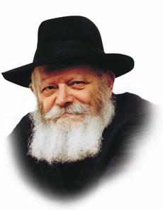

For the past few weeks we have been reading those Torah portions dealing with the commandments and preparations necessary for the building of the Tabernacle. This week, in Vayakhel, we read about its actual erection.
Before the Tabernacle was built, Moses called together all of the Children of Israel and commanded them to keep the Sabbath. "Six days shall work be done, and on the seventh you shall have a holy day. A Sabbath of rest to G-d."
The Talmud explains that the juxtaposition of Shabbat and the building of the Tabernacle teaches us which types of work we must avoid in order to keep the Sabbath. These are the 39 categories of labor which are prohibited on Shabbat, and from which are derived all other activities which may not be pursued on the holy day.
Nothing in the Torah occurs coincidentally. The fact that the Torah chooses the building of the Tabernacle to teach us which labors are prohibited on Shabbat shows that there is a connection between these two subjects. Furthermore, the relationship between Shabbat and the building of the Tabernacle has another, deeper dimension. Every one of the 39 types of labor involved in building the Sanctuary is the prototype of the labors we perform during the six days of the week. And, because everything in the physical world reflects its spiritual source, all our physical labor is the building of the Tabernacle. All the work which we perform has the potential to be elevated and turned into holiness.
But not only is the Tabernacle the source for the work in our lives, it also serves as our lives' goals as well. Every task we perform during our daily routine should be utilized to bring holiness into the world, the same function which the original Tabernacle served.
The Torah states: "Six days shall you work." Our Sages explain that this is a positive commandment, not merely the granting of permission. Man is compelled to toil to earn his daily bread. We see that the prayers and Torah readings prescribed for weekdays are shorter than those read on Shabbat and holidays, to enable a person to go out into the world to perform his daily tasks. It is through one's physical labor that he molds and shapes the world into a "sanctuary" for G-d.
How do we elevate our daily, mundane tasks? "In all your ways shall you know Him," explains the Torah. All of our activities, no matter how seemingly trivial, must be performed with the proper thoughts in mind. When we eat, drink, sleep and go about our business according to Torah law, we are cognizant of our Creator and transform our lives into sanctuaries to G-d.
The basic difference between the Tabernacle and our own physical world is that the Tabernacle was an actual manifestation of G-dliness, whereas the physical world is still in a state of potential. Man's task is to transform that potential into actual realization, by living according to the dictum, "In all your ways shall you know Him."

Reprinted from Issue #205 of L’Chaim Weekly (Parshat Vayakhel 5752/1992).

Rav Avigdor Miller on
Leaping without Looking

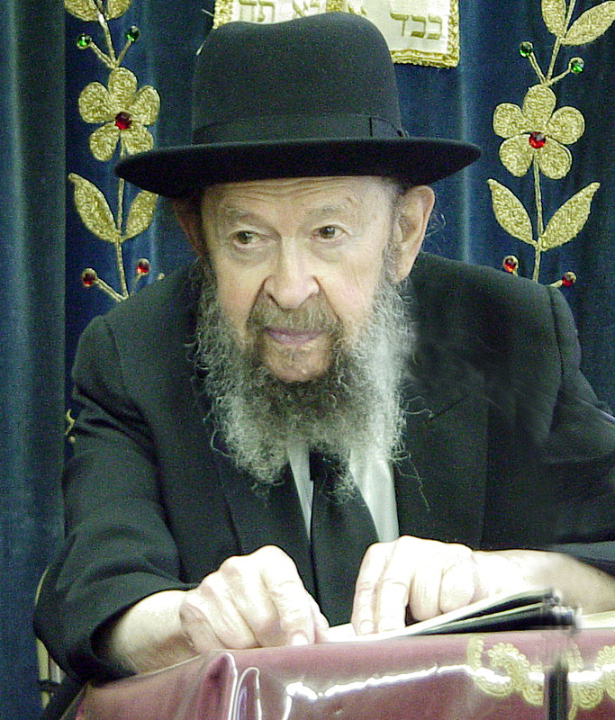
QUESTION: Is there such a thing as being too picky when looking for a wife? Shouldn't someone be able to chose what is right so that they can be happy?
ANSWER: I remember a young man I knew who was very picky. So I asked him, "How many girls did you go out with already?"
"One hundred girls," he tells me. A hundred girls! So I told him, "Something is wrong with you. If out of those one hundred girls you couldn't find at least ten girls to fall in love with, then something is wrong."
Hakodosh Boruch Hu made girls so that men should fall in love with them. Therefore it doesn't take that long to find the right one. Certainly you should choose the one you like. Of course - why not? But you cannot continue looking forever.
When you reach the age of twenty-five it's already time to have made a decision. Even earlier, but today twenty-five is the cut-off time. At that point already you should stop choosing. Just close your eyes and listen to the advice that other people are telling you.
And if people who are capable are telling you, "This is a fine girl. She's healthy. She comes from a good family. She's idealistic," then just go ahead and leap without looking. TAPE # 630 (March 1987)

Reprinted from the March 4, 2018 email of Toras Avigdor.

